

**Experiment 05: Write a program to implement date and time picker. MIHIR GHARAT ROLL NO 37 TECOMP B**

**Learning Objective:** Student should be able to write a program to implement date and time picker in Android Studio.

**Tools:** Android Studio

**Theory:**

**Android Studio:**

Android Studio is the official integrated development environment (IDE) for Android application development. Every project in Android Studio has one or more modalities with source code and resource files. These modalities include Android app modules, Library modules, and Google App Engine modules. It is an open source software platform and operating system for mobile devices which is based on the Linux kernel. It allows writing managed code in the Java language and Kotlin language. Android apps are built as a combination of components that can be invoked individually. For example, an activity is a type of app component that provides a user interface (UI). The "main" activity starts when the user taps the application's icon. One can also direct the user to an activity from elsewhere, such as from a notification or even from a different app. Other components, such as broadcast receivers and services, allow the application to perform background tasks without a UI.

Data and Time Picker:

Android Date Picker allows coder to select the date consisting of day, month and year in the custom user interface. For this functionality android provides DatePicker and DatePickerDialog components.

The DatePickerDialog class consists of a 5 argument constructor with the parameters listed below.

• Context: It requires the application context

• CallBack Function: onDateSet() is invoked when the user sets the date with thefollowing parameters:

• int year : It will be store the current selected year from the dialog

• int monthOfYear : It will be store the current selected month from the dialog

• int dayOfMonth : It will be store the current selected day from the dialog

• int mYear : It shows the the current year that’s visible when the dialog pops up

• int mMonth : It shows the the current month that’s visible when the dialog pops up

• int mDay : It shows the the current day that’s visible when the dialog pops up

The TimePickerDialog class consists of a 5 argument constructor with the parameters listedbelow.

• Context: It requires the application context

• CallBack Function: onTimeSet() is invoked when the user sets the time with thefollowing parameters:

• int hourOfDay : It will be store the current selected hour of the day from the dialog

• int minute : It will be store the current selected minute from the dialog

• int mHours : It shows the the current Hour that’s visible when the dialog pops up

• int mMinute : It shows the the current minute that’s visible when the dialog pops up

• boolean false : If its set to false it will show the time in 24 hour format else not

**Implementation:**

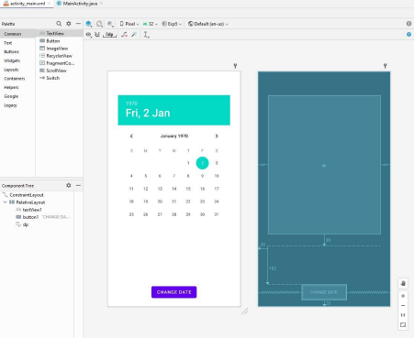

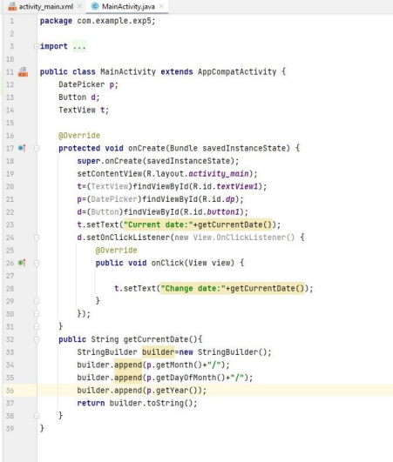

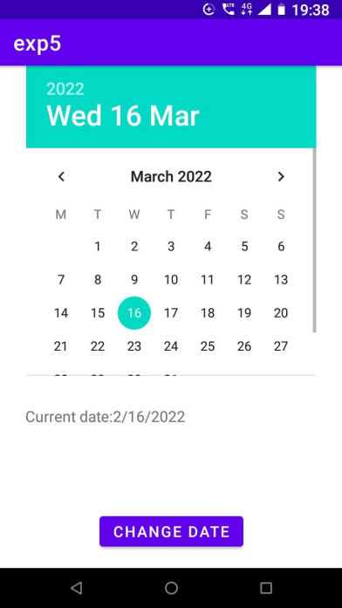

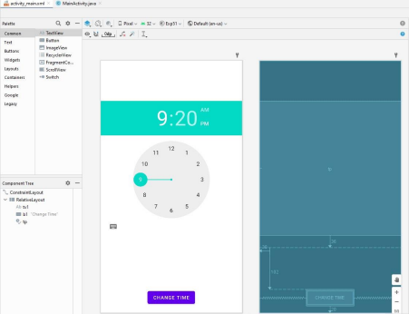

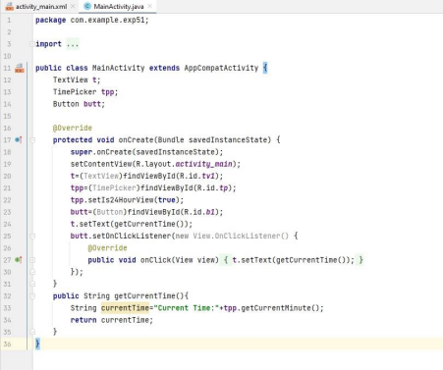

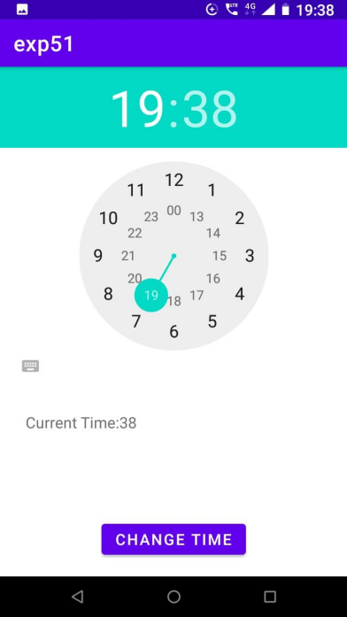

**Conclusion:**

We understood in this experiment the concept of date and time picker in android studios. Furthermore the DatePickerDialog class and TimePickerDialog class along with their respective parameters were understood. We implemented program that allows user to pick theirdate of birth and select a particular time slot. The program was executed on the Android VirtualDevice.